St. Robert Catholic High School

Happenings -Week of June 19
Monday | June 19 | Day 2
All Day | IPP Release Day | J.Buckley, L.Loffredi, D.Chan, Denise Zucchetto, L.Laviolette, J.Babic?
9:00am | Admin Meeting – Principal’s Office | Admin Team
10:00am – 12:30pm | MYSP Video Contest Recognition Ceremony – Library Closed | D.Chan, Pat Preston, Carl Cotton, all students who participated in the MYSP Video Contest
Tuesday | June 20 | Day 1
All Day | IB Workshop | S.Pulla, J.Thome
12:00pm | Grade 12 Religion Exams – as per schedule | Please check exam Supervision Schedule
2:45pm | Academic Council – Library | Admin, Dept. Heads
Wednesday | June 21 | Day 2
All Day | IB Workshop | S.Pulla, J.Thome
9:00am | Exams Day 1 | Please check exam Supervision Schedule
Thursday | June 22 | Day 1
All Day | IB Workshop | S.Pulla, J.Thome
9:00am | Exams Day 2 | Please check exam Supervision Schedule
Friday | June 23 | Day 2
All Day | IB Workshop | S.Pulla, J.Thome
9:00am | Exams Day 3 | Please check exam Supervision Schedule

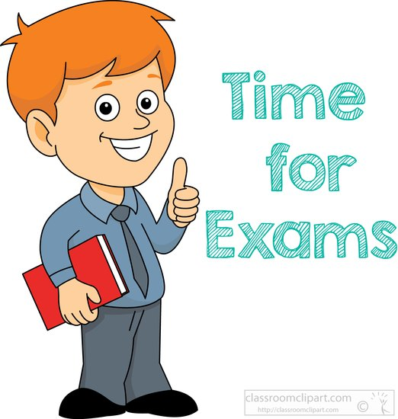

Morning Announcements | Afternoon Prayer | Detention Room
P.Sacco | Students | A.Steele

Cafeteria/Bus Duty
June 19-20 | Lunch A  11:13-11:53 | Lunch B  11:53-12:33 | Lunch C  12:33-1:13 | Bus Duty  2:32-2:45
Day 1 | Mastrangelo  Mazzacca | Scarcello  TBD | Di Nunzio  Giang | Rosa  Sarracini
Day 2 | Westacott  Loffredi | Lothian  Paolucci | Nardi  Purdon

Upcoming News
June 21-27 | Exams
June 28 | Exam Review Day
June 29 | PA Day
June 29 | Graduation 2017 Ceremony
June 30 | PA Day
June 30 | End-of-Year Staff Meeting
July 7 | Report Cards Home

Information/Social News
Please direct all Personal Social Announcements to Denise Zucchetto & Angela McMahon
June 29 @ 3:30pm | Retirement social for 2017 Retirees @ SMASH Kitchen & Bar

Please check your “myPortal” account
or
System Memos via YCDSB.ca for
all job postings

